# **REQUIREMENT 8 – DATA GENERATION**

*27/08/2024*

# **Information:**

* **Group 13:** 21127234 – Nguyễn Lê Anh Chi

# **Tools used:**

* Data generation: Mockaroo (<https://www.mockaroo.com/>) - Mockaroo allows you to quickly and easily to download large amounts of randomly generated test data based on your own specs which you can then load directly into your test environment using SQL or CSV formats. No programming is required.
* Insert data: Katalon Studio.

🡪 Use Mockaroo to generate Excel file then use Katalon data-driven method to insert data.

# **Process:**

* 1. **Generate 50 users:**
  + Set up:

* + Data:

* + Import data to Katalon:

* + Run Test Suite:

* + Result:

* 1. **Generate 20 test plan:**
  + Set up:

* + Data:

* + Import Data to Katalon:

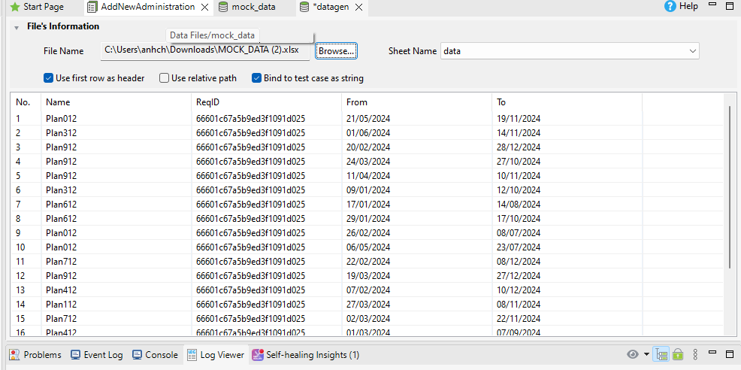

* + Run Test Suite:

